**Week 2**

**VaultofCodes**

**Python Programming Internship**

TASK: Write a program to count word frequencies in a given text

ALGORITHM:

Step 1: Get the input text from the user.

Step 2: Spilt the given text into words.

Step 3: Initialize a dictionary to store the word frequency count.

Step 4: Convert the given code into lowercase text to avoid case sensitive errors.

Step 5: Now make a loop to check and count each word in the given sample text. If the word already exists add 1 to its frequency count else make/keep its frequency count as 1 only.

Step 6: Now finally display the word frequency counts for the user.

CODE:

text = input("Enter the text: ")

words = text.split()

word_freq = {}

for word in words:

word = word.lower()

if word in word_freq:

word_freq[word] += 1

else:

word_freq[word] = 1

for word, freq in word_freq.items():

print(f"{word}: {freq}")

OUTPUT:

Enter the text: Life in the forest is a reflection of the natural world . The natural world is a treasure trove of wisdom and beauty . Beauty that has inspired poets , artists , and explorers for centuries . Centuries of human history have passed , yet the enchanting allure of the forest remains as strong as ever .

life: 1

in: 1

the: 5

forest: 2

is: 2

a: 2

reflection: 1

of: 4

natural: 2

world: 2

.: 4

treasure: 1

trove: 1

wisdom: 1

and: 2

beauty: 2

that: 1

has: 1

inspired: 1

poets: 1

,: 3

artists: 1

explorers: 1

for: 1

centuries: 2

human: 1

history: 1

have: 1

passed: 1

yet: 1

enchanting: 1

allure: 1

remains: 1

as: 2

strong: 1

ever: 1

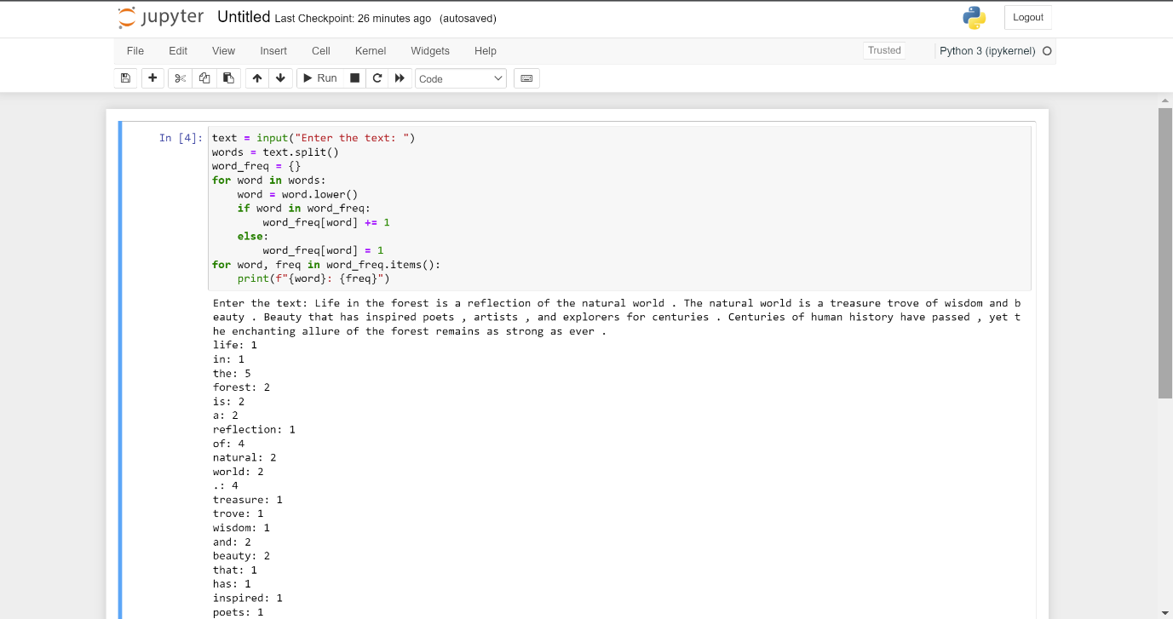

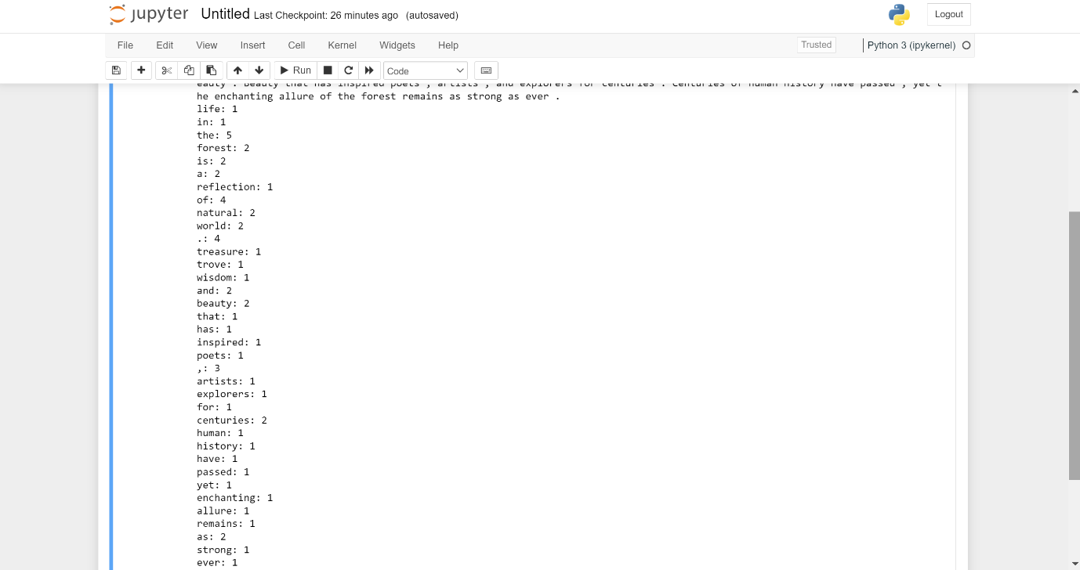

Mini Project: Develop a basic to-do list program using functions and data structures and add features like adding tasks in the to-do list, display the tasks and quitting the loop

ALGORITHM:

Step 1: Define the “display to-do tasks” function.

Step 2: Define the “add task” function.

Step 3: Define the “remove task” function.

Step 4: Now write the main function to display all these options to the user and continue with respect to the options they choose.

CODE:

def display(to_do_list):

if not to_do_list:

print("Your to-do list is empty.")

else:

print("To-Do List:")

for index, task in enumerate(to_do_list, start=1):

print(f"{index}. {task}")

def add(to_do_list, task):

to_do_list.append(task)

print(f"Task '{task}' added to the to-do list.")

def remove(to_do_list, task_index):

if 1 <= task_index <= len(to_do_list):

removed_task = to_do_list.pop(task_index - 1)

print(f"Task '{removed_task}' removed from the to-do list.")

else:

print("Invalid task index. No task removed.")

def main():

to_do_list = []

while True:

print("\nMain Menu:")

print("1. Display To-Do List")

print("2. Add Task")

print("3. Remove Task")

print("4. Quit")

choice = input("Choose your menu option (1/2/3/4): ")

if choice == "1":

display(to_do_list)

elif choice == "2":

task = input("Enter the task you want to add: ")

add(to_do_list, task)

elif choice == "3":

task_index = int(input("Enter the task index to remove: "))

remove(to_do_list, task_index)

elif choice == "4":

print("Adiós!")

break

else:

print("Invalid choice. Please choose 1, 2, 3, or 4.")

if __name__ == "__main__":

main()

OUTPUT:

Main Menu:

1. Display To-Do List

2. Add Task

3. Remove Task

4. Quit

Choose your menu option (1/2/3/4): 1

Your to-do list is empty.

Main Menu:

1. Display To-Do List

2. Add Task

3. Remove Task

4. Quit

Choose your menu option (1/2/3/4): 2

Enter the task you want to add: python programming internship task

Task 'python programming internship task' added to the to-do list.

Main Menu:

1. Display To-Do List

2. Add Task

3. Remove Task

4. Quit

Choose your menu option (1/2/3/4): 2

Enter the task you want to add: meet the doctor

Task 'meet the doctor' added to the to-do list.

Main Menu:

1. Display To-Do List

2. Add Task

3. Remove Task

4. Quit

Choose your menu option (1/2/3/4): 3

Enter the task index to remove: 5

Invalid task index. No task removed.

Main Menu:

1. Display To-Do List

2. Add Task

3. Remove Task

4. Quit

Choose your menu option (1/2/3/4): 3

Enter the task index to remove: 1

Task 'python programming internship task' removed from the to-do list.

Main Menu:

1. Display To-Do List

2. Add Task

3. Remove Task

4. Quit

Choose your menu option (1/2/3/4): 1

To-Do List:

1. meet the doctor

Main Menu:

1. Display To-Do List

2. Add Task

3. Remove Task

4. Quit

Choose your menu option (1/2/3/4): 3

Enter the task index to remove: 1

Task 'meet the doctor' removed from the to-do list.

Main Menu:

1. Display To-Do List

2. Add Task

3. Remove Task

4. Quit

Choose your menu option (1/2/3/4): 1

Your to-do list is empty.

Main Menu:

1. Display To-Do List

2. Add Task

3. Remove Task

4. Quit

Choose your menu option (1/2/3/4): 4

Adiós!

